BookHouse

Software Development Plan

Version <1.1>

Revision History

| **Date** | **Version** | **Description** | **Author** |
| --- | --- | --- | --- |
| 30/10/2021 | 1.0 | First plan | HKTT group |
| 11/11/2021 | 1.1 | Modify deadline |  |
|  |  |  |  |
|  |  |  |  |

Table of Contents

**1.** **Introduction 4**

**2.** **Project Overview 4**

*2.1* *Project Purpose, Scope, and Objectives 4*

*2.2* *Assumptions and Constraints 4*

*2.3* *Project Deliverables 4*

**3.** **Project Organization 4**

*3.1* *Organizational Structure 4*

*3.2* *Roles and Responsibilities 4*

**4.** **Management Process 4**

*4.1* *Project Estimates 4*

*4.2* *Project Plan 4*

4.2.1 Phase and Iteration Plan 5

4.2.2 Releases 5

4.2.3 Project Schedule 5

4.2.4 Project Resourcing 5

*4.3* *Project Monitoring and Control 5*

4.3.1 Reporting 5

4.3.2 Risk Management 5

4.3.3 Configuration Management 6

Software Development Plan

# 

# Introduction

* This document is to provide the plan for developing the BookHouse project, which includes: Project overview, team organization, project schedule and tools used during the project.

# Project Overview

## Project Purpose, Scope, and Objectives

Purpose:

* Create a website for online book selling. The website can meet the requirements of many avid readers in VietNam (especially in remote areas).

Scope:

* In this project we just focus on the creation of a website for book selling in VietNam.

Objectives:

* A friendly interface.
* High performance.
* Adequate functions for customers and the administrators.
* Make sure the functions of the application work correctly.

## Assumptions and Constraints

* Project has a fixed schedule of 12 weeks.
* Zero-budget project.
* Project has 4 people, there will be no more people added during the project.

## Project Deliverables

* Web interface design (20/11/2021).
* Use-case model (13/11/2021).
* Use-case specification (13/11/2021).
* Database design (27/11/2021).
* Web structure design (27/11/2021).
* Work Breakdown Structure (30/10/2021).
* Gantt chart (30/10/2021).
* Test cases (12/12/2021).
* Test cases result (21/12/2021).

# Project Organization

## Organizational Structure

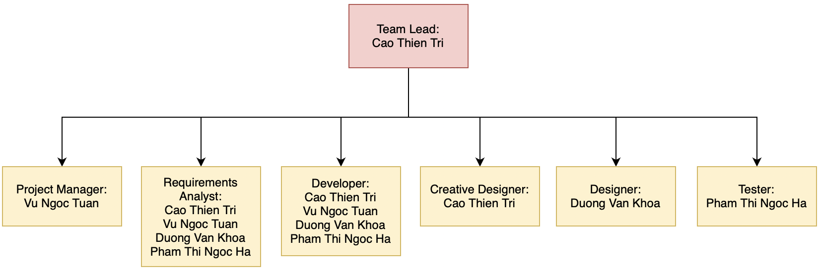

## Roles and Responsibilities

| ***Person*** | ***Role*** |
| --- | --- |
| Cao Thien Tri | Creative Designer, **Team Leader**, Developer, Requirements Specialist |
| Pham Thi Ngoc Ha | Tester, Developer, Requirements Specialist |
| Duong Van Khoa | Designer, Developer, Requirements Specialist |
| Vu Ngoc Tuan | Project Manager, Developer, Requirements Specialist |

# Management Process

## Project Estimates

* The estimation is well described in session 4.2 and would not be presented again in this session.

## Project Plan

### Phase and Iteration Plan

| Task | Start | End |
| --- | --- | --- |
| Inception phase, define general requirements for the project. | 23-10-2021 | 30-10-2021 |
| Elaboration phase, complete the initial design of the interface, software and the database. | 31-10-2021 | 27-11-2021 |
| Construction phase, remaining use cases will be analyzed and designed. The first version will be released, the implementations and the testers will be completed to support developing the next version. | 28-11-2021 | 18-12-2021 |
| Final test - fix bugs. The tester will implement the system testing, simulate the end user to execute the application and fix the bugs before transferring to the users. | 19-12-2021 | 25-12-2021 |
| Official release, deploy the website to the server, collect feedback from users. | 26-12-2021 | 8-1-2022 |

### Releases

* The first prototype will have minimal function and data for an online book store to re-analyze the design, it would be released on 4/12/2021.
* The second version is to measure the performance of the software, debug and plan for improvements if needed (18/12).
* The third version is the final release (25/12/2021).

### Project Schedule

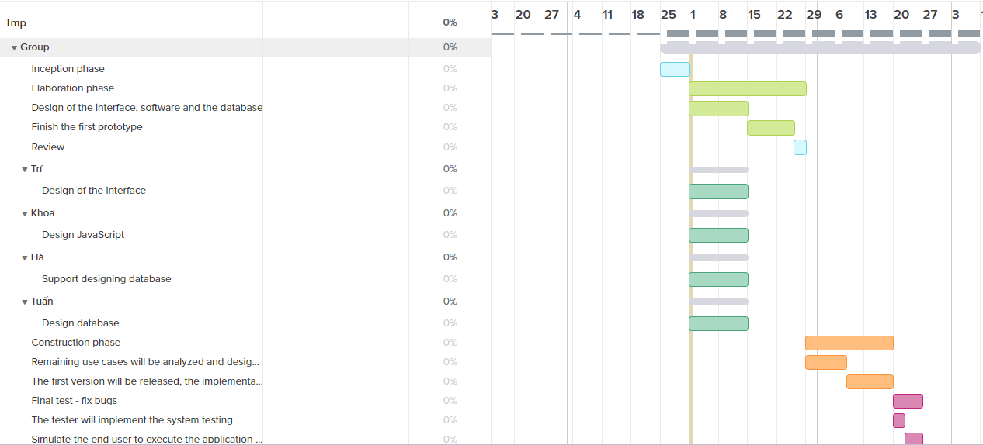

## Project Monitoring and Control

### Reporting

* Weekly report
* Weekly scrum
* Planning minutes
* Sprint review

### Risk Management

| *Risk ID* | *Risk Description* | *Probability* | *Impact* | *Priority* | *Mitigation Strategy or Contingency Plan* |
| --- | --- | --- | --- | --- | --- |
|  |  |  |  |  |  |
|  |  |  |  |  |  |
|  |  |  |  |  |  |

### Configuration Management

* Google drive for storing and sharing files, documents.
* Git for managing source code and related files.
* Trello for time scheduling and task assignment.
* Workflow for design interface.